**Question 02:**

**EMPLOYEE** (Entity) has the following attributes:

* **Employee ID (identifier)**
* **Name**
* **Address**
* **Birthdate**

**PROJECT** (Entity) has the following attributes:

* **Project ID (identifier)**
* **Project Name**
* **Start Date**

Each project is assigned to one or more Employees and each Employee is assigned to one or more projects. This means the relationship is named as **Assignment**.

* **Each employee may be assigned to one or more projects or may not be assigned to a project:** This means that the cardinality between EMPLOYEE and PROJECT is zero or many because each employee can be assigned to none or many projects.
* **A project must have at least one employee assigned and may have any number of employees assigned:** This means the project and employee have a one or many relationship because a project has one or many employees assigned to it.

**Assumption:** Address is a multivalued attribute because it has alphanumeric values (i think).

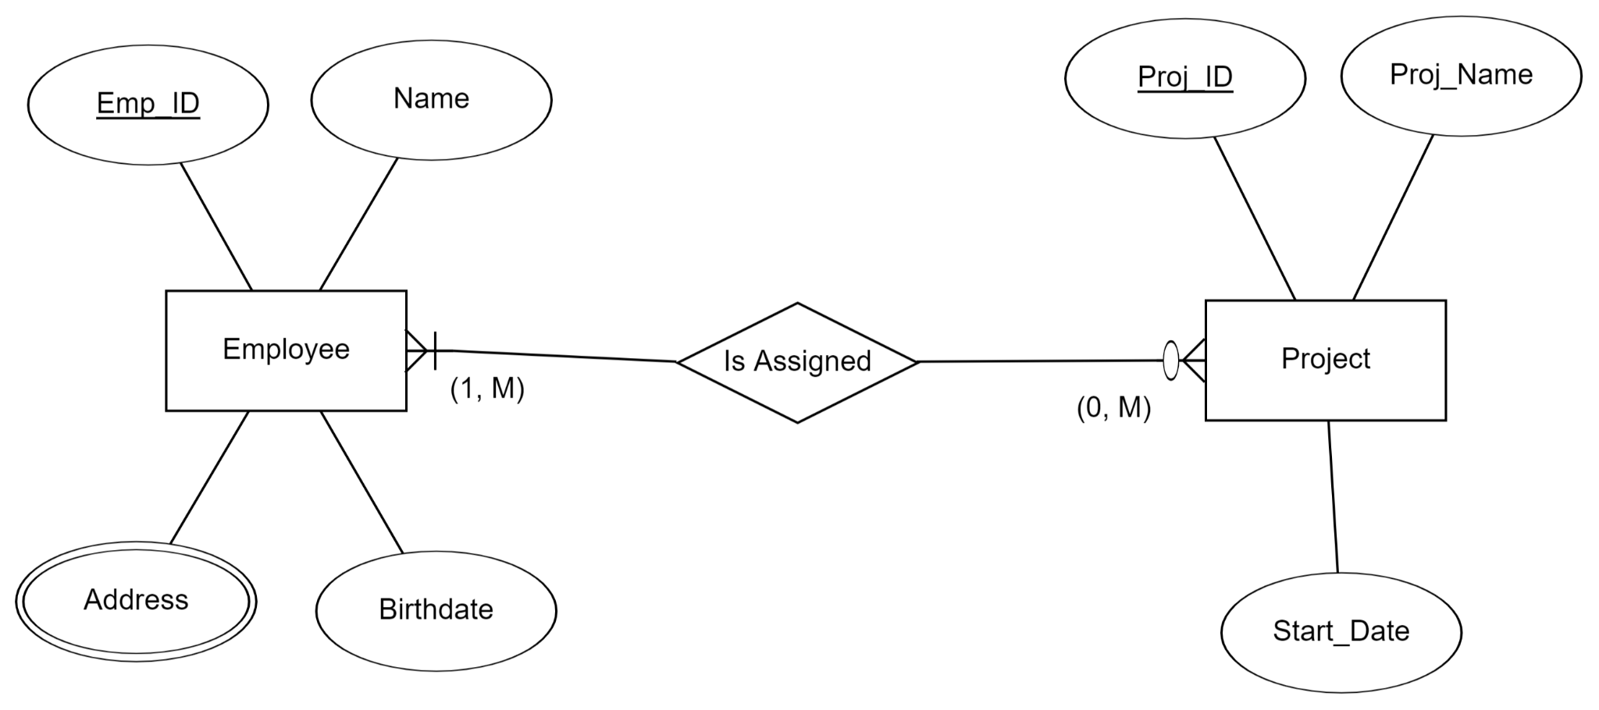

For the Assignment relationship, it is represented as an entity because the company wishes to record the applicable billing rate (Billing_Rate) for each employee when assigned to a particular project. So Billing_Rate becomes an attribute of Assignment.

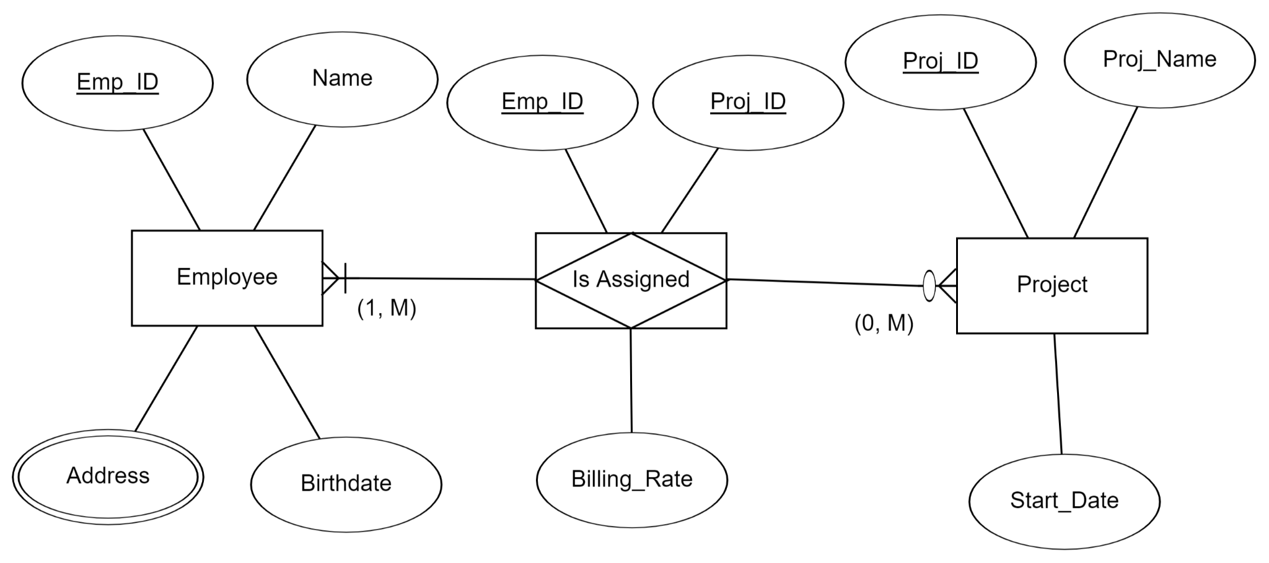

**Question 03:**

Companies, identified by a Company_ID and described by Company_Name and Industry_Type, hire consultants, identified by Consultant_ID and described by Consultant_Name, Consultant_Speciality, which is multivalued. Assume that a consultant can work for only one company at a time, and we need to track only current consulting engagements. A company can also have multiple consultants working for them, or at times, they have no need of consultants.

**(a): Draw an ERD for this Situation:**

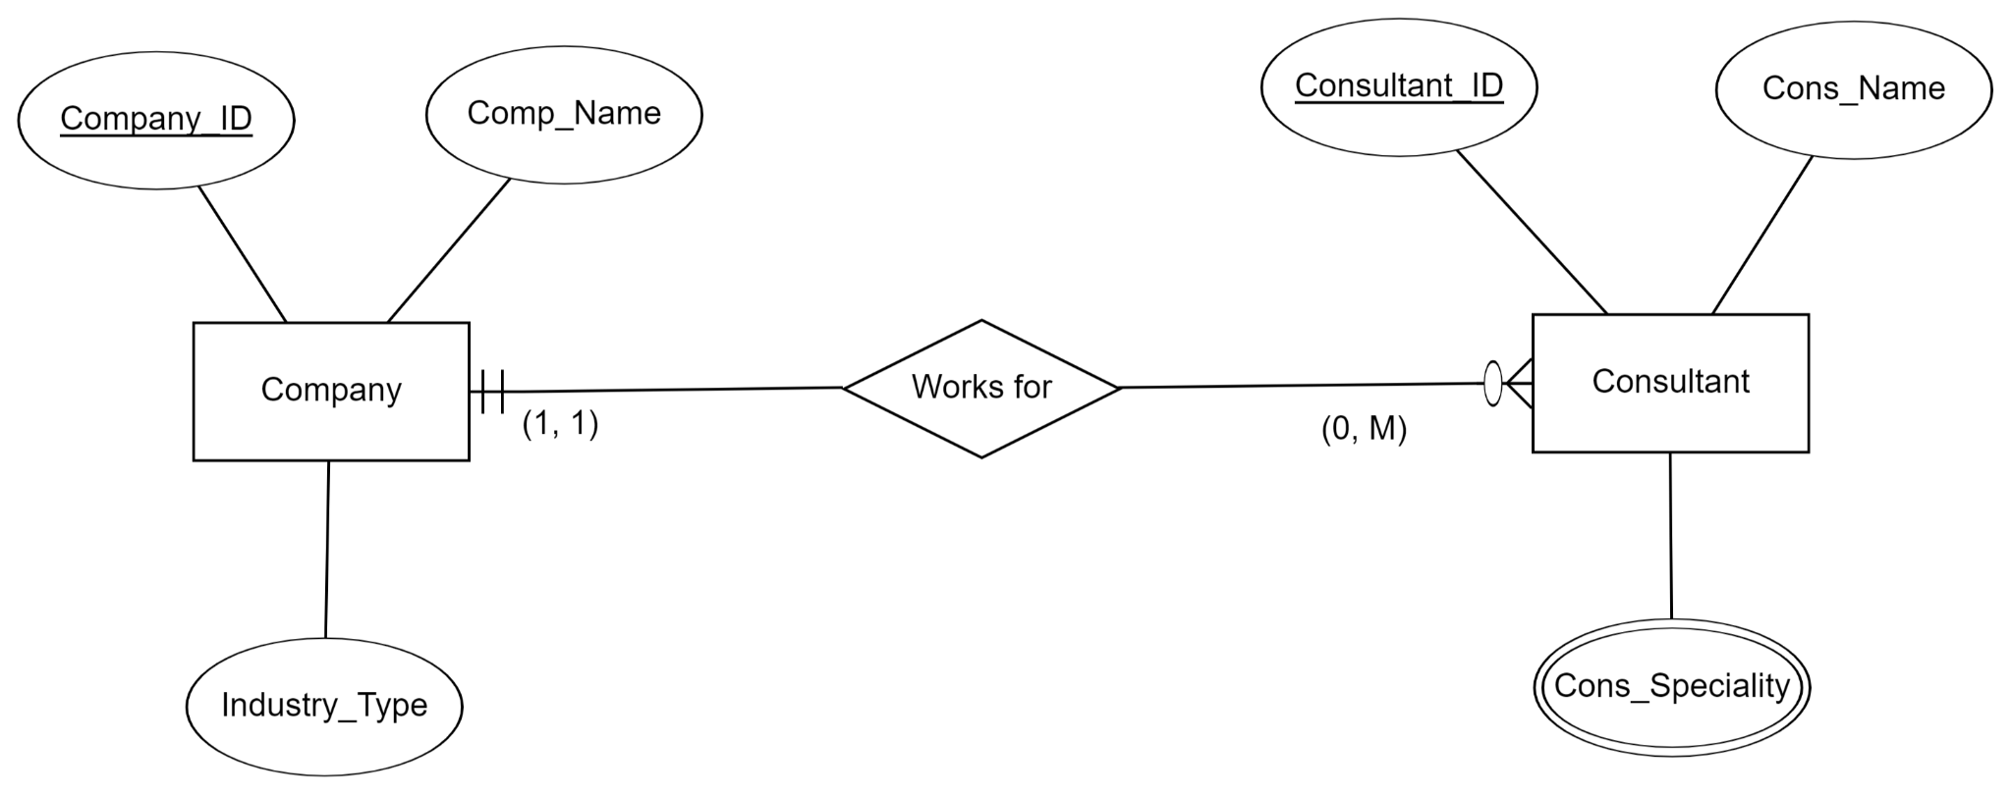

Now, consider that each time a consultant works for a company, a contract is written describing the terms for this consultant engagement. Contract is identified by a composite identifier of Company ID, Consultant ID, and Contract Date. The contract should also include the hourly rate at which the consultant is paid. Assuming the consultant can still work for only one company at a time.

**(b): Redraw the ERD for this situation.**

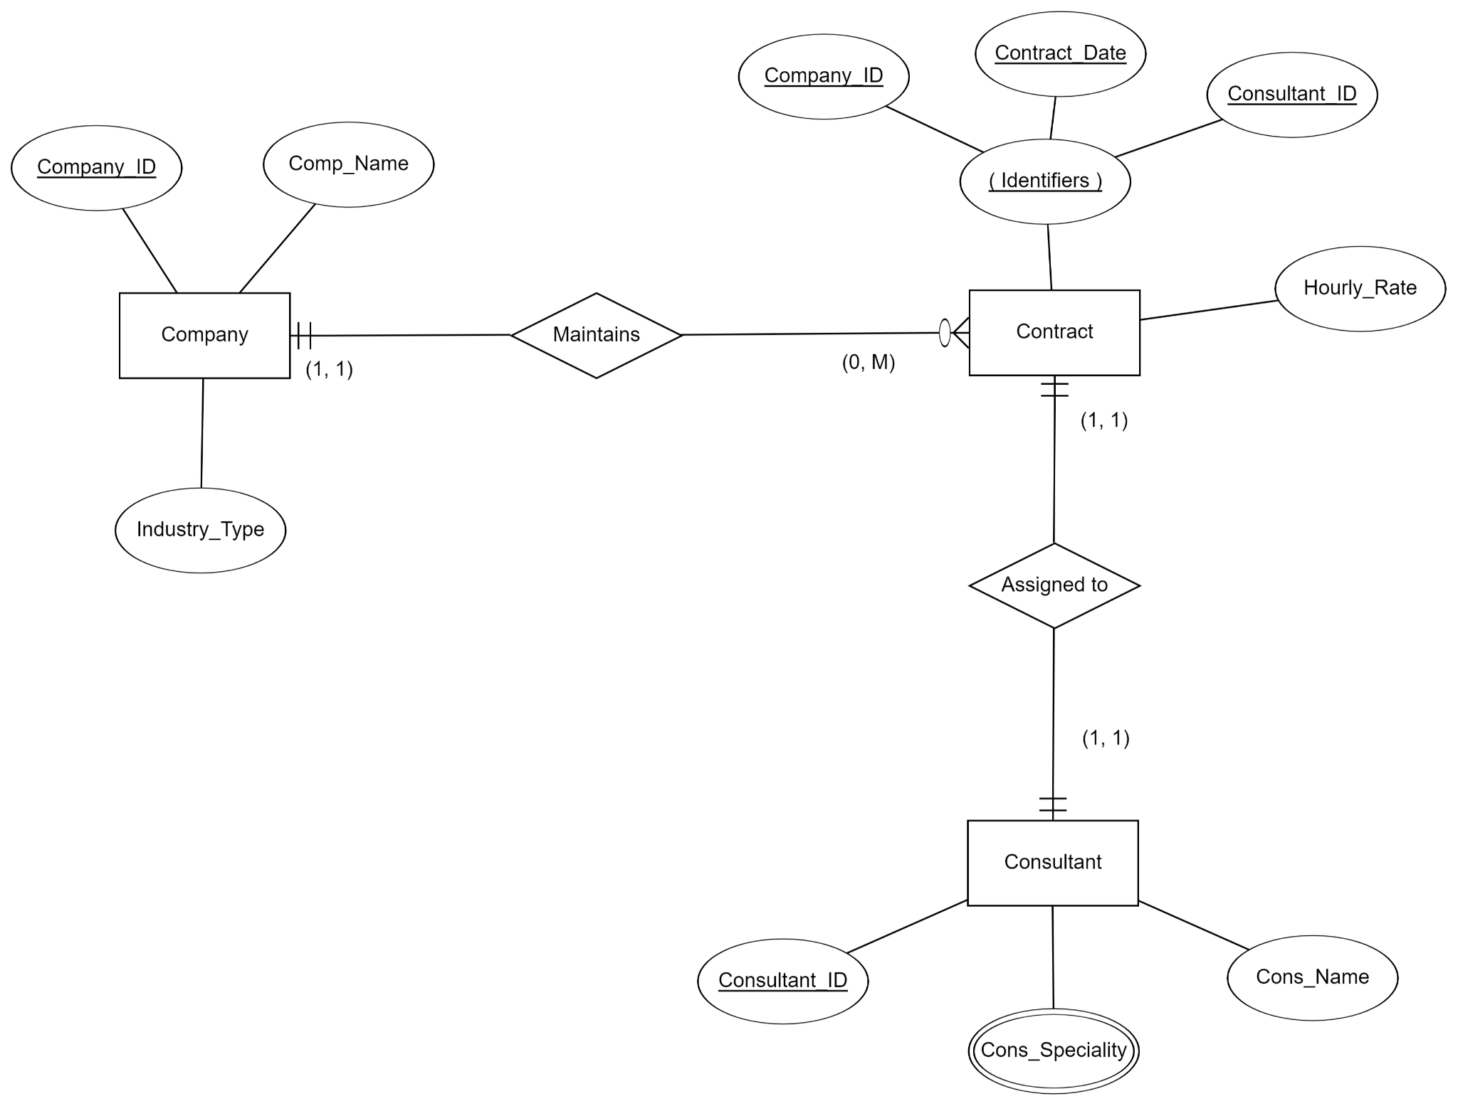

**Question 04:**

The ERD for the hospital situation consists of three main entity types, PHYSICIAN, PATIENT, and TREATMENT. The relationships between these entities allow for the tracking of multiple admissions and treatments over time. The hospital is not included as an entity as it has no attributes or relationships to be recorded in this model. Moreover, I am assuming that both Physician and Patient have IDs that are Primary Keys (identifiers). Also assuming that, details are Composite

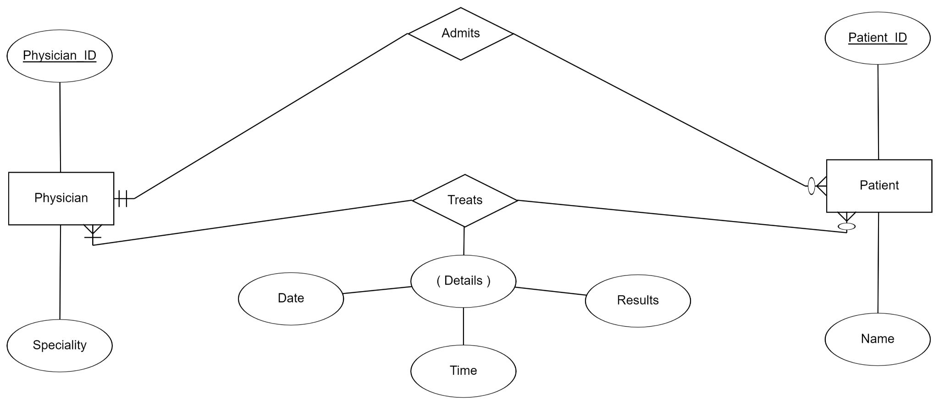

In other Notation we can also draw ERD as:

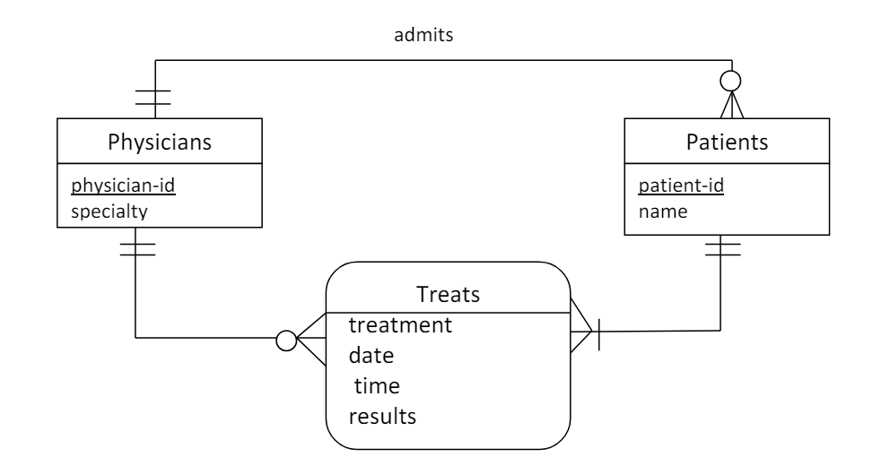

**Question 05:**

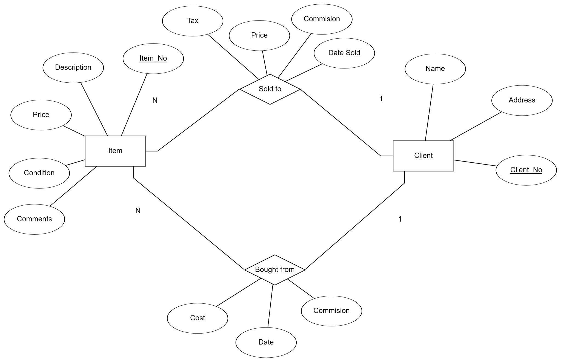

However, if i use the (min, max) notation with the Assumptions that a Client must have a minimum of 1 Item bought or sold and that for Item the minimum is 1 and maximum is M. Then, we can also use the following ERD:

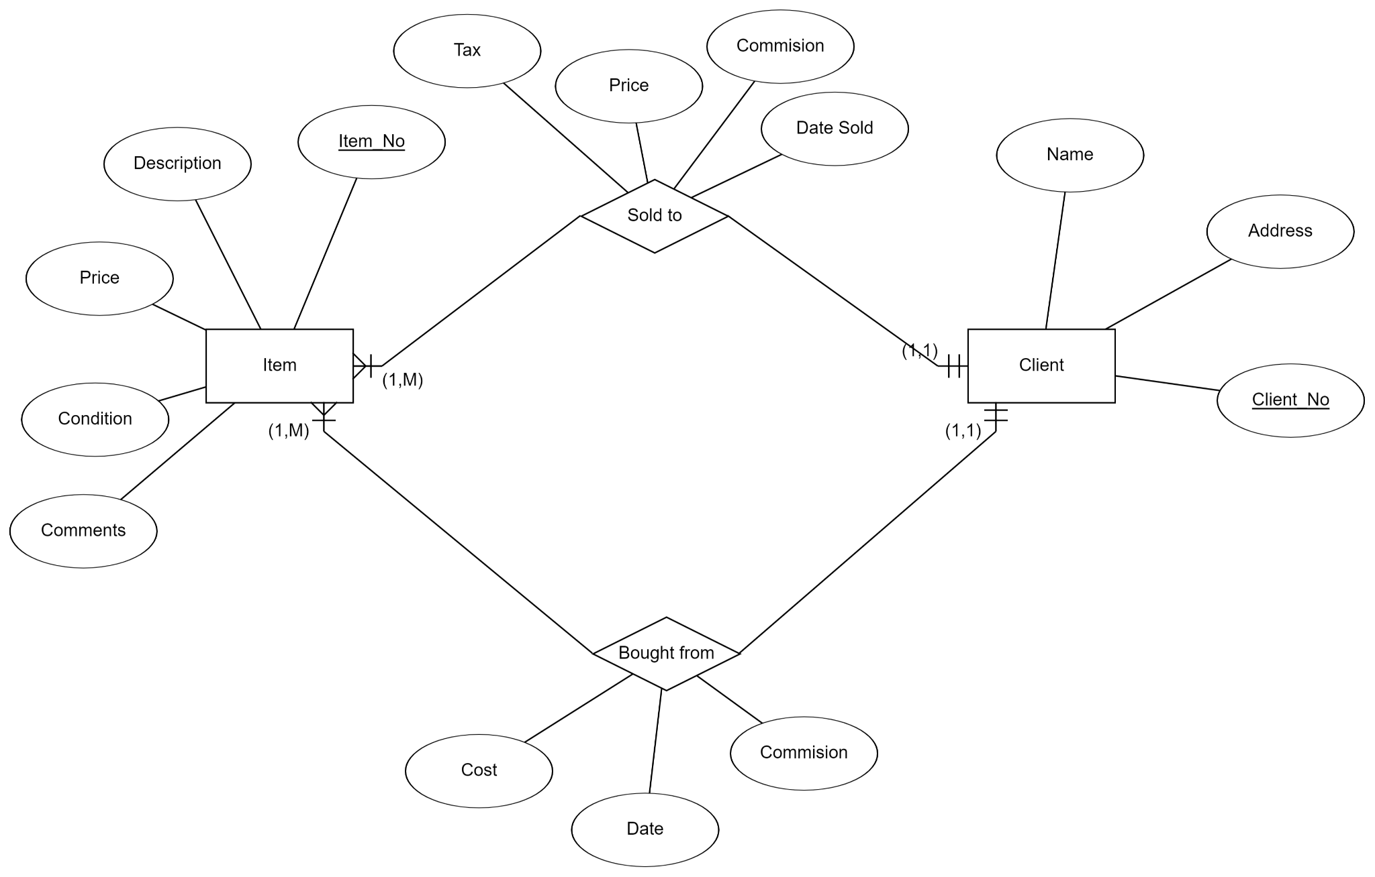

**Question 06:**

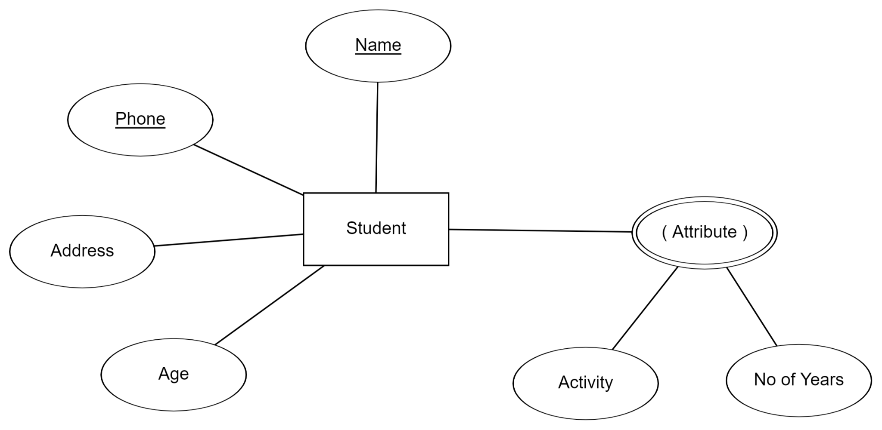

Here I have taken both Name and Phone as a Composite Primary Key (identifier). You can take Name only as an identifier, but then it is possible that 2 people might have the same name. But 2 people with the same Name and Phone (with the same country code) isn’t really possible. Moreover, Attribute is both a Multivalued key and Composite satisfying the condition of [Student may engage in more than one activity].

**Question 07:**

An associative entity is an entity type used for associating one or more entity instances that have a many-to-many relationship. It contains attributes important for all entity instances that are associated with the associative entity.

A good example is an associative entity that associates entity instances of Book and Customer entity types. A new entry is created each time when the Customer borrows a book in the bookstore.

A weak entity is an entity whose existence is dependent on the other (strong) entities. It doesn't have its identifier, ie: it is identified by the primary attribute of the strong entity that is implemented as a foreign key in the weak entity.

So, Associative entities are a type of weak entity because they cannot exist on their own and are dependent on other entities in the many-to-many relationship. The speciality about their weakness is that they are dependent on both entities that are forming the relationship that needed the associative entity to resolve their relationship.

**Question 08:**

Given Functional Dependencies:

* **StaffID → StaffName**
* **CustomerID → Cust_Name, Cust_Address**
* **Cust_Address → Cust_Phone**
* **OrderID → OrderDate, CustomerID, StaffID**
* **FoodDishID → FoodDishName, UnitPrice**
* **OrderID, FoodDishID → Quantity, QuantityPrice**

The definition of partial dependency is that if a relation has a candidate key that consists of more than one attribute, and if an attribute is dependent on only a part of that candidate key, then such a dependency is referred to as partial dependency. First finding all Candidate Keys:

From above FDs, we can infer that:

* StaffID identifies StaffName.
* CustomerID identifies Cust_Name and Cust_Address.
* Cust_Address identifies Cust_Phone.
* OrderID identifies OrderDate, CustomerID and StaffID.
* FoodDishID identifies FoodDishName and UnitPrice.
* Combination of OrderID and FoodDishID identifies Quantity, QuantityPrice.

According to the rules of Partial Dependency:

1. **Left side of the arrow in a functional dependency:** Must be a proper subset of any candidate key.
2. **Right side of the arrow in a functional dependency:** Must be a non-prime attribute.

This way to Convert the given 1NF in the first Step is to find the Candidate Keys, which in this case are OrderID and FoodDishID. First checking 1NF, as LHS of 6th Dependency LHS is a proper Subset of both Candidate Keys so it is in a 1NF Form. So to convert to 2NF, we divide the table into 3 tables.

**Relation 1:** OrderID, OrderDate, CustomerID, StaffID, StaffName, Cust_Name, Cust_Address, Cust_Phone.

* CustomerID → Cust_Address, Cust_Name
* Cust_Address → Cust_Phone
* OrderID → StaffID, CustomerID, OrderDate
* StaffID → StaffName

**Relation 2:** FoodDishId, FoodDishName, UnitPrice.

* FoodDishId → FoodDishName, UnitPrice

**Relation 3:** OrderID, FoodDishId, Quantity, QuantityPrice

* FoodDishId, OrderID → Quantity, QuantityPrice

These 3 Relations describe the 2NF Form. Now for 3NF, we remove the Transitive Dependencies. Find the minimal cover of FDs, which contains

* StaffID → StaffName
* CustomerID → Cust_Name
* CustomerID → Cust_Address
* Cust_Address → Cust_Phone
* OrderID → OrderDate
* OrderID → CustomerID
* OrderID → StaffID
* FoodDishId → FoodDishName
* FoodDishId → UnitPrice
* OrderID, FoodDishId → Quantity
* OrderID, FoodDishId → QuantityPrice

Merge FDs with same LHS and whose RHS are non-key attributes, we get the given set which contains:

* StaffID → StaffName
* CustomerID → Cust_Address, Cust_Name
* Cust_Address → Cust_Phone
* OrderID → StaffID, CustomerID, OrderDate
* FoodDishId → UnitPrice, FoodDishName
* OrderID,FoodDishId → QuantityPrice, Quantity

Check each FD in the set F1 for violation of 3NF, and split the table accordingly.

Checking FD [StaffID → StaffName]. The FD violates 3NF as its LHS is not a superkey (and RHS is a set of non-key attributes). The following 3NF table is obtained:

* StaffID, StaffName with FDs StaffID → StaffName.

Checking FD [CustomerID → Cust_Address, Cust_Name]. The FD violates 3NF as its LHS is not a superkey (and RHS is a set of non-key attributes). The following 3NF table is obtained:

* CustomerID, Cust_Address, Cust_Name with FDs CustomerID → Cust_Address, Cust_Name.

Checking FD [Cust_Address → Cust_Phone]. The FD violates 3NF as its LHS is not a superkey (and RHS is a set of non-key attributes). The following 3NF table is obtained:

* Cust_Address, Cust_Phone with FDs Cust_Address → Cust_Phone.

Checking FD [OrderID → StaffID, CustomerID, OrderDate]. The FD violates 3NF as its LHS is not a superkey (and RHS is a set of non-key attributes). The following 3NF table is obtained:

* OrderID, StaffID, CustomerID, OrderDate with FDs OrderID → CustomerID, StaffID, OrderDate.

Checking FD [FoodDishId → UnitPrice, FoodDishName]. The FD violates 3NF as its LHS is not a superkey (and RHS is a set of non-key attributes). The following 3NF table is obtained:

* FoodDishId, UnitPrice, FoodDishName with FDs FoodDishId → UnitPrice, FoodDishName.

Checking FD [OrderID, FoodDishId → QuantityPrice, Quantity]. FD does not violate 3NF. No change done. Thus the table is now in 3NF. For BCNF, we can check if LHS of the Arrow is a Super Key or not. If it is not, we split the table into 2 or more (only sometimes). The final Relations for BCNF are:

**Relation 1:** StaffID, StaffName

* StaffID → StaffName

**Relation 2:** Cust_Address, Cust_Phone

* Cust_Address → Cust_Phone

**Relation 3:** CustomerID, Cust_Address, Cust_Name

* CustomerID → Cust_Address, Cust_Name

**Relation 4:** OrderID, CustomerID, StaffID, OrderDate

* OrderID → CustomerID, StaffID, OrderDate

**Relation 5:** FoodDishId, FoodDishName, UnitPrice

* FoodDishId → FoodDishName, UnitPrice

**Relation 6:** OrderID, FoodDishId, Quantity, QuantityPrice

* OrderID, FoodDishId → Quantity, QuantityPrice

This final table is in BCNF Form. All requirements are satisfied. You can also check the Ruf Work for this Question at the End of the Document.

**Question 09:**

We are given the relation R(ABCDEFGH), and FDs {AB → C, AC → B, AD → E, B → D, BC → A, E → G}. Turning the relation into its lowest form by removing its dependencies, we get ABFH.

Taking the closure of ABFH, we get {A, B, C, D, E, F, G, H}, so it can be called a super key. But, closure of BFH gives {B, D, F, H} which means it is not a candidate key. Similarly, the closure of AFH gives {A, F, H}, thus it is also not a candidate key. Thus, ABFH is one candidate key. Closure of ACFH gives all values in the relation, ie: {A, B, C, D, E, F, G, H}. While, taking closure of AFH and CFH does not give all values in the Relation. So, ACFH is a Candidate key.

Moreover, the closure of BCFH gives all values in the relation mainly {B, C, A, D, E, G, F, H}. So, BCFH is a Candidate key. There are 3 candidate keys: **ABFH, ACFH, BCFH.** Moreover, the Paper written version of this Question is also given at the End of this Document. Moreover, the Diagrams in this Assignment have been created using [ERDPlus](https://erdplus.com/). The Source Files for each Document have been attached to Google Classroom.

**NEXT PAGE**

**Question 08 (Hand Written):**

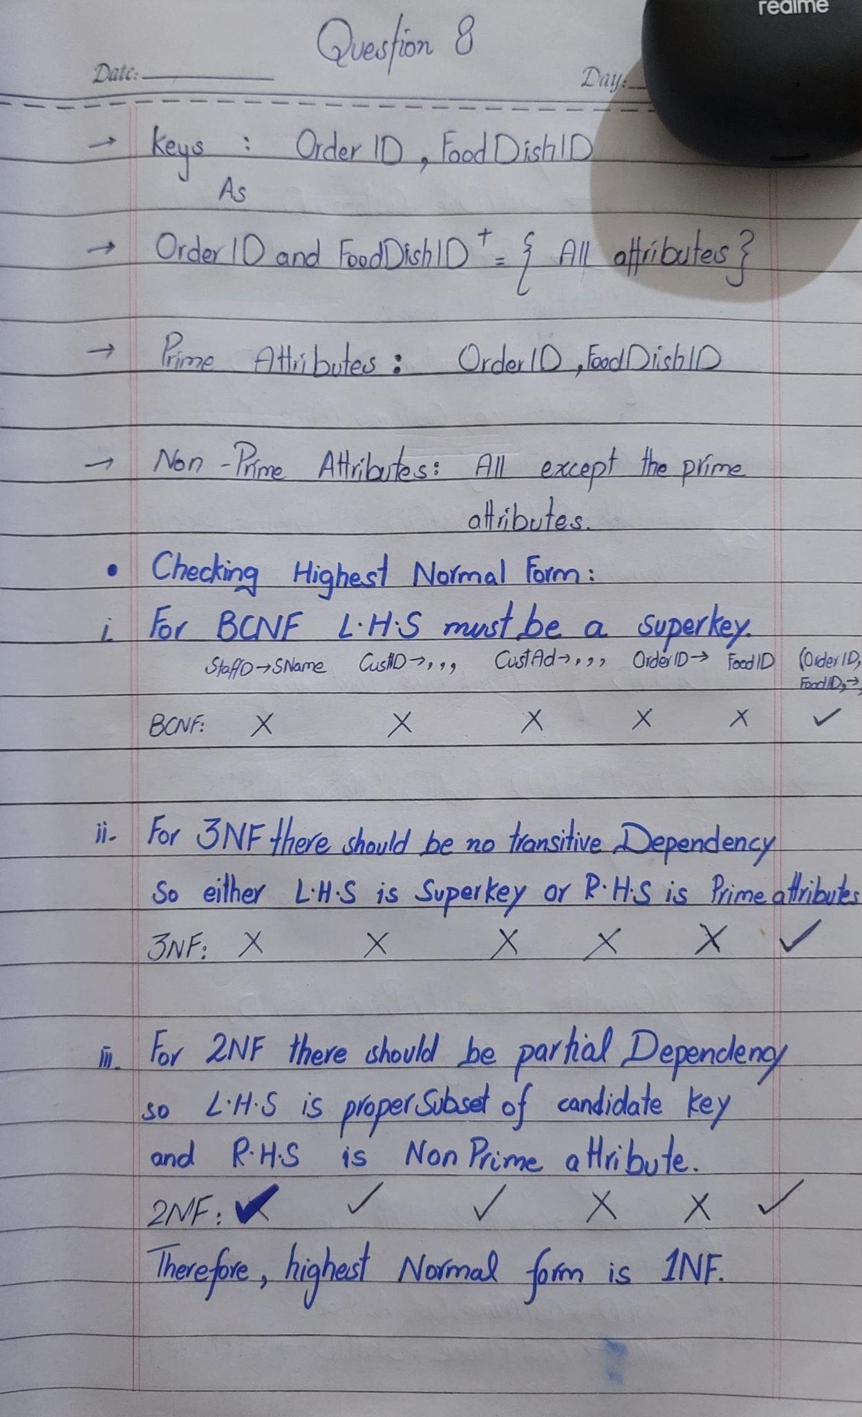

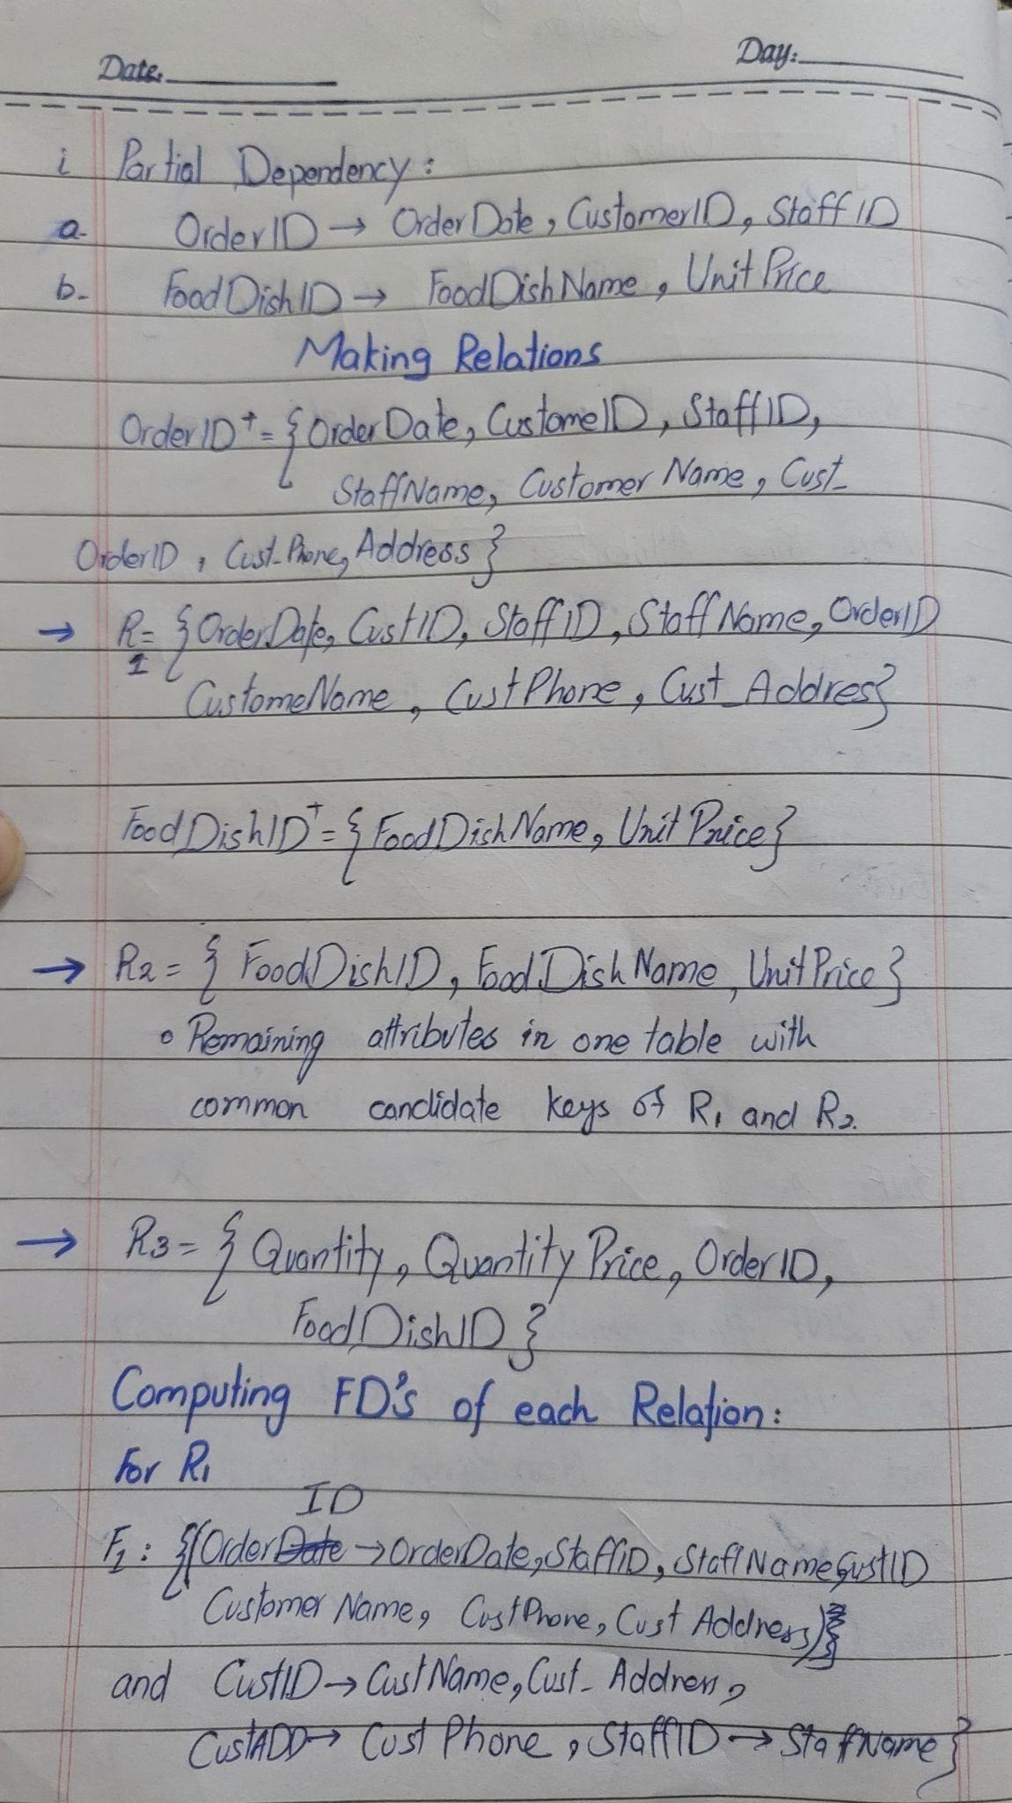

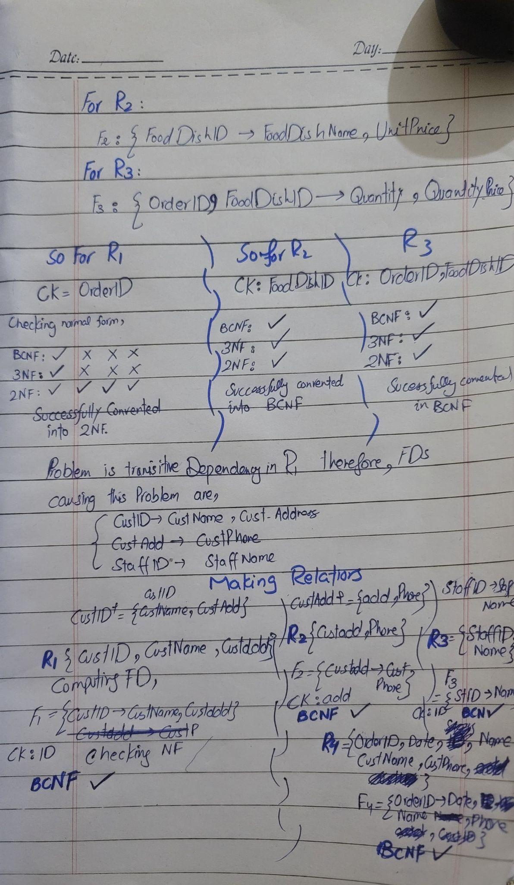

**Question 09 (Handwritten):**

